Monitoring PaperCut NG System Health using Zabbix

You can use the third-party tool Zabbix ([www.zabbix.com](http://www.zabbix.com/)) to monitor the overall state of your print environment. This includes but is not limited to getting real-time updates on aspects such as device inactivity, outages, trends in printing resources and usage, etc.

To use Zabbix to monitor your PaperCut NG Application Server you need the following:

* **Python 2.x or 3.x** – Python 2.x or 3.x must be installed on your PaperCut NG Application Server.   
  For more information on Python for Windows, see [Download Python for Windows](https://www.python.org/downloads/) and [How to Install Python on Windows](https://www.howtogeek.com/197947/how-to-install-python-on-windows/).
* **Zabbix Server** – The Zabbix Server must already be installed and set up. For more information, see [How To Install and Configure Zabbix to Securely Monitor Remote Servers on CentOS 7](https://www.digitalocean.com/community/tutorials/how-to-install-and-configure-zabbix-to-securely-monitor-remote-servers-on-centos-7).
* **Zabbix agent** – The Zabbix agent must be configured using the following steps:

Step One – Get the PaperCut NG System Health Monitoring details 2

Step Two – Access the Zabbix Server Admin web interface 2

Step Three – Create a PaperCut NG host group on the Zabbix Server Admin web interface 3

Step Four – Create a PaperCut NG host on the Zabbix Server Admin web interface 3

Step Five – Import the Zabbix template for your PaperCut host 4

Step Six – Configure PaperCut NG host macros 8

Step Seven – Install the Zabbix agent on the PaperCut NG Application Server 9

On Windows: 9

On Linux: 11

Step Eight – Verify PaperCut NG System Health is monitored by Zabbix 13

## Step One – Get the PaperCut NG System Health Monitoring details

1. Log in to the PaperCut MF Admin web interface:  
   http://<PaperCut-Server-IP>:9191/admin
2. Navigate to **Options > Advanced**
3. In the **System Health Monitoring** section’s **Authorization - GET query parameter** fieldtake note of the following:
   * **The PaperCut NG Application Server authorization key:**  
     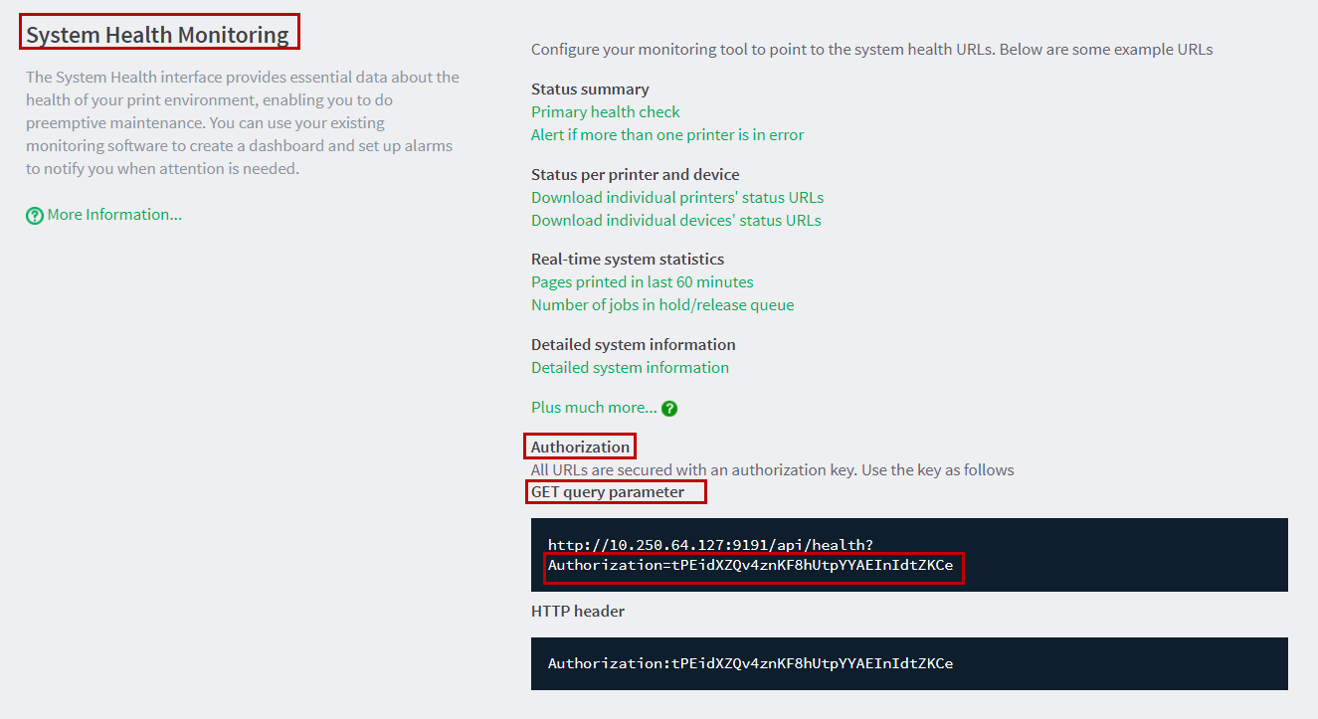
   * **The PaperCut NG Application Server IP address:  
     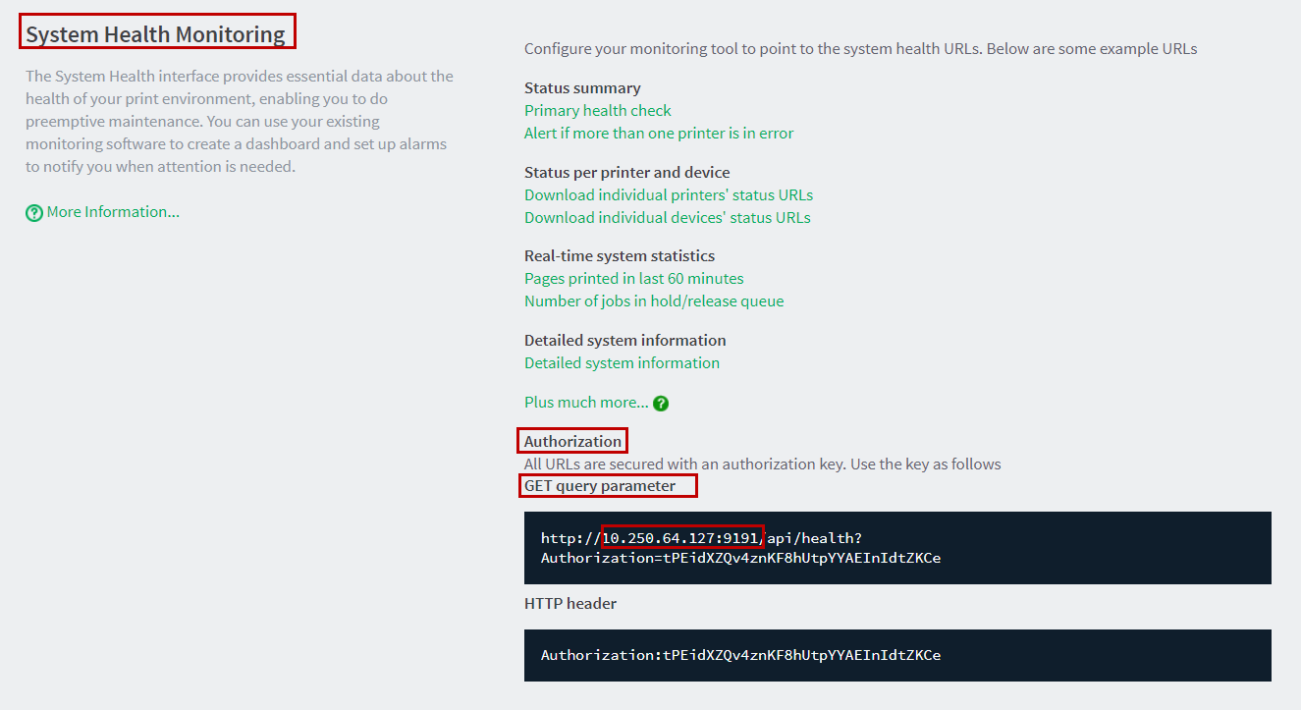**
   * **The PaperCut NG Application Server URL:  
     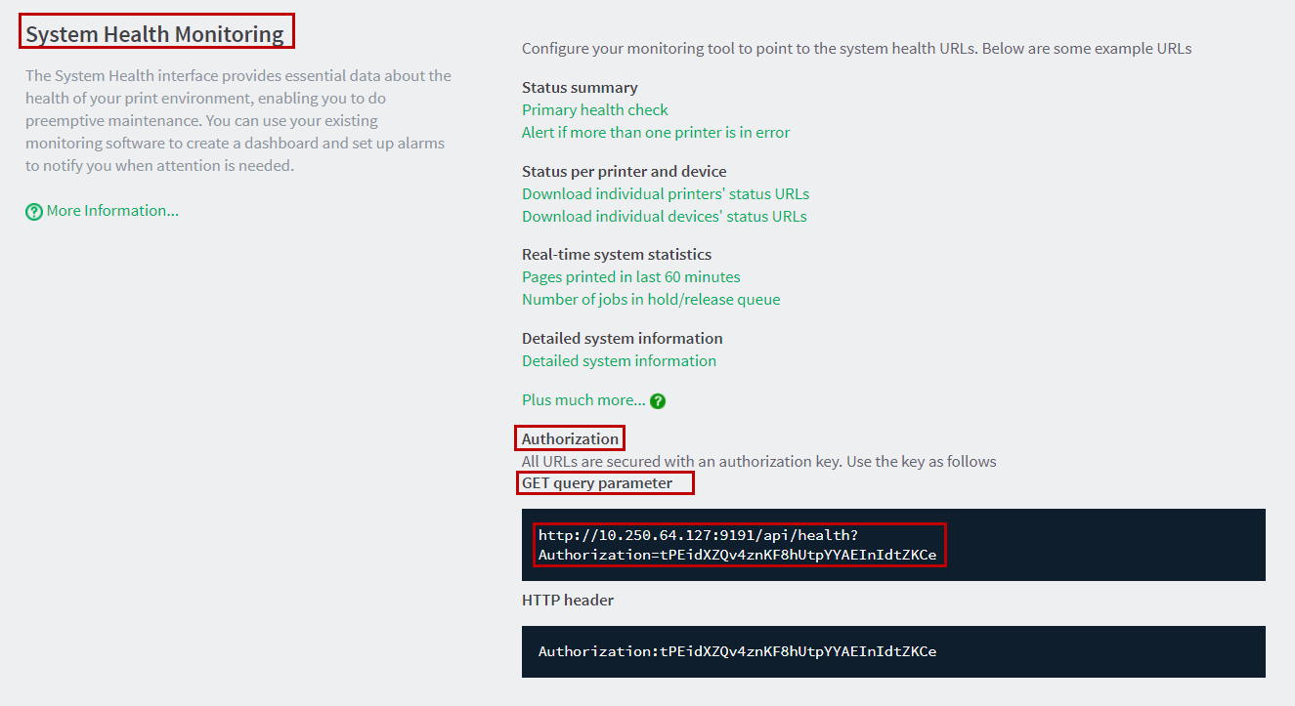**

## Step Two – Access the Zabbix Server Admin web interface

To access the Zabbix Server Admin web interface:

1. Log in to the Zabbix Server Admin web interface:   
   http://<server ip or hostname>/Zabbix
2. Enter the Zabbix Server Administrator credentials:   
   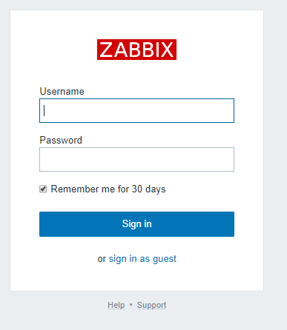
3. Click **Sign in**.

## Step Three – Create a PaperCut NG host group on the Zabbix Server Admin web interface

To create a PaperCut NG host group on the Zabbix Server Admin web interface:

1. Access the Zabbix Server Admin web interface.
2. Navigate to **Configuration > Host Groups** and click **Create host group**:

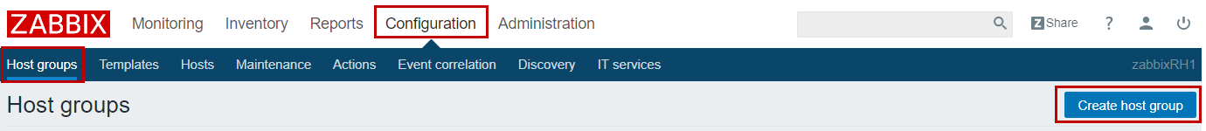

1. Enter the relevant **Group name** and click **Add**:

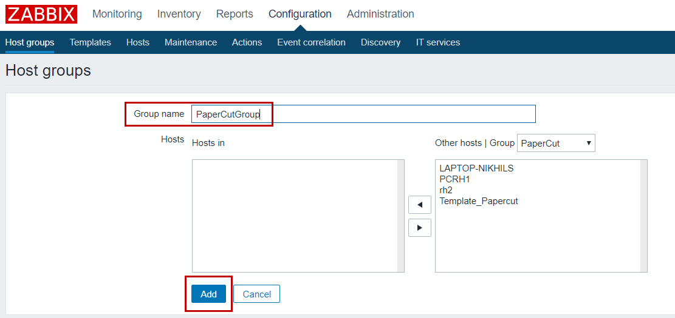

1. Verify that the PaperCut NG host group you just created is on the **Configuration > Host groups** page:

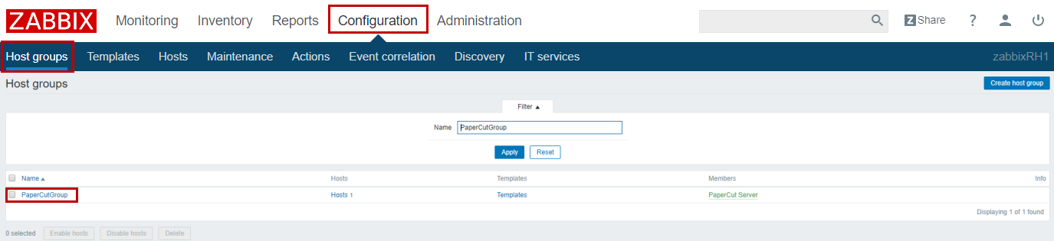

## Step Four – Create a PaperCut NG host on the Zabbix Server Admin web interface

To create a PaperCut NG host on the Zabbix Server Admin web interface:

1. Access the Zabbix Server Admin web interface.
2. Navigate to **Configuration > Hosts** and click **Create host**:

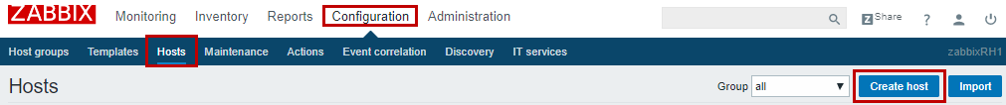

1. Change the default settings of only the following fields and click **Add**:

**Host name –** Name of your PaperCut NG Application Server (exclude the **FQDN**).

**Visible name** – Easily identifiable name of your PaperCut NG host on the Zabbix Server.

**Groups** – Select the PaperCut NG host group (you just created) from the **Other groups** list and click the **<** button, to add it into the **In Groups** list.

**Agent interfaces** **IP address** – Enter the IP address of your PaperCut NG Application Server noted from the **Authorization - GET query parameter** of the PaperCut MF Admin web interface. For example, 10.250.64.127:9191

**Agent interfaces Port** – Enter the port used to communicate with your PaperCut NG Application Server (9191).

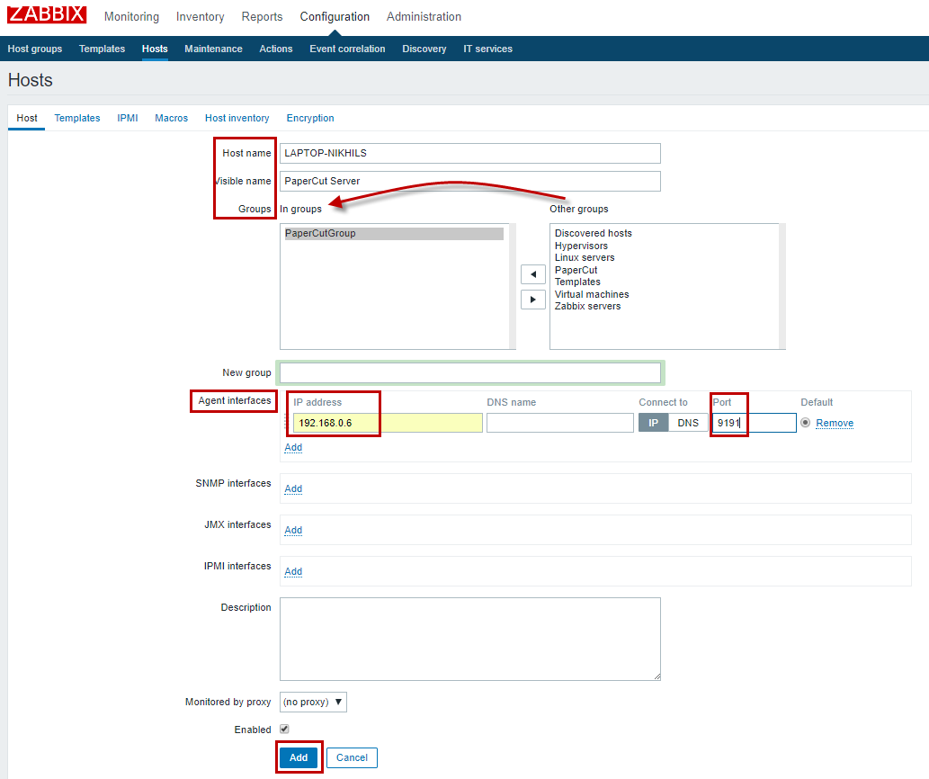

1. Verify that the PaperCut NG host you just created is on the **Configuration > Hosts** page:

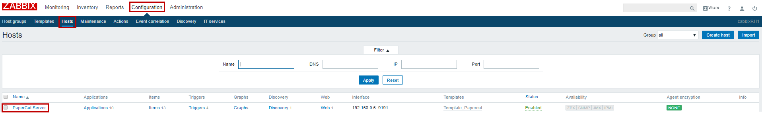

## Step Five – Import the Zabbix template for your PaperCut host

To import the Zabbix template for your PaperCut host:

1. Navigate to:   
   <https://github.com/Open-Future-Belgiu9m/zabbix-papercut/tree/master/template>
2. Right click the **zabbix_papercut_template.xml** file and select **Save link as…**:  
   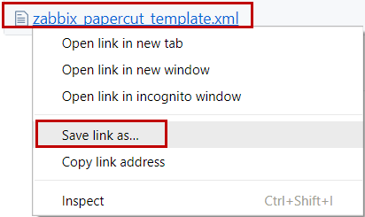
3. Save the file in to your local directory:  
   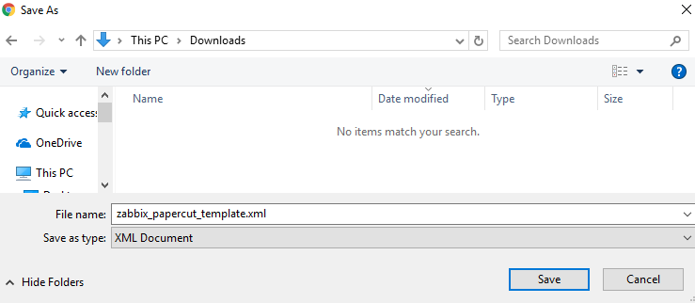
4. Access the Zabbix Server Admin web interface.
5. Navigate to **Configuration > Templates** and click **Import**:

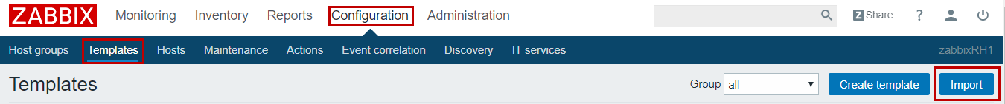

1. On the **Import file** field, click **Choose File**:

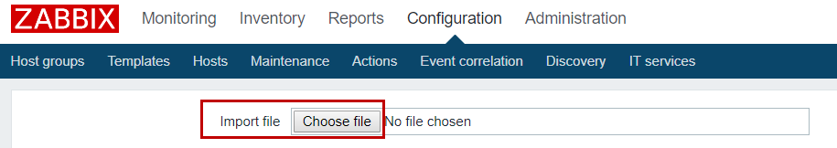

1. Locate and select the **zabbix_papercut_template.xml** file saved in your local directory and click **Open**:  
   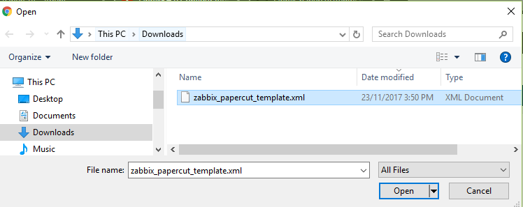
2. Verify that the **Import file** field displays the **zabbix_papercut_template.xml** file:  
   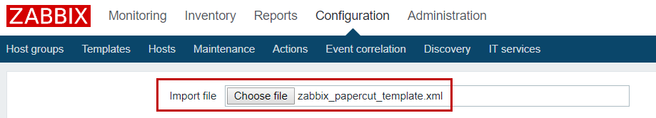
3. Do not change the default settings of the **Rules** fields:  
   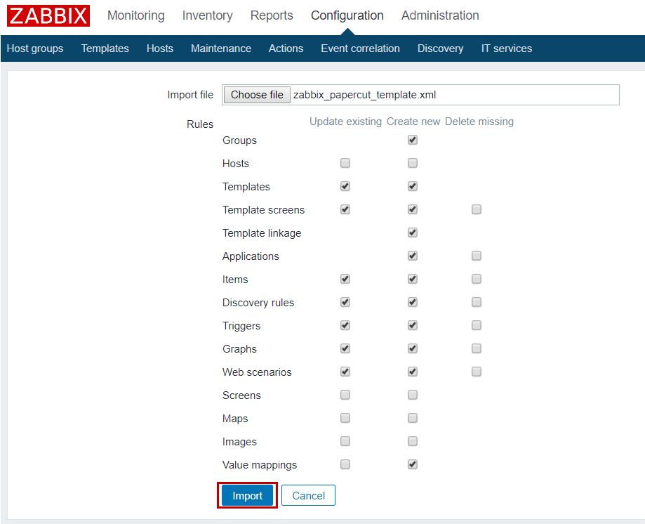
4. Click **Import:**
5. Verify that the Zabbix template for your PaperCut host that you just imported is on the **Configuration > Templates** page as **Template_PaperCut**.  
   **Note:** To search for and locate the template, specify **Template_PaperCut** as the search filter on the **Name** field and click **Apply**.   
   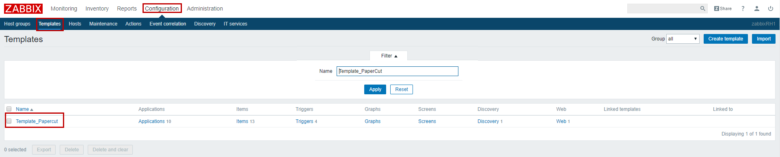
6. Click the Zabbix template for your PaperCut host that you just imported, **Template_PaperCut**.
7. Change the default settings of only the following field and click **Update**:

**Hosts / templates** – Select the PaperCut host group (you just created) from the **Other | group** drop down and click the **<** button, to add it into the **In** list.  
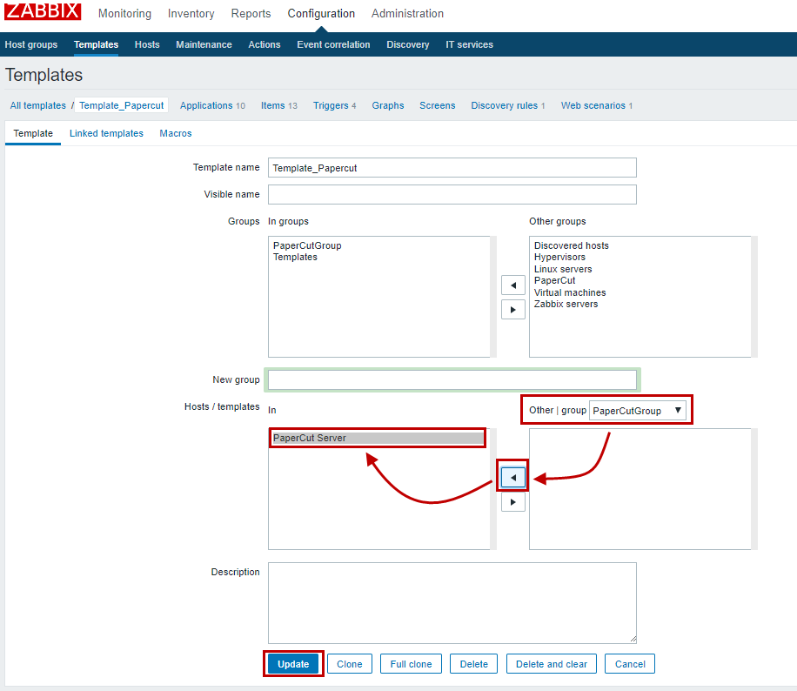

1. Verify that the Zabbix template for your PaperCut host that you just imported (**Template_PaperCut**) on the **Configuration > Templates** page is **Linked to** the **PaperCut Server**:  
   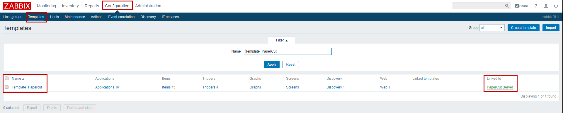

## Step Six – Configure PaperCut NG host macros

To configure macros for your PaperCut NG host:

1. Access the Zabbix Server Admin web interface.
2. Navigate to **Configuration > Hosts** and clickthe PaperCut NG host (your just created):



1. Navigate to **Macros > Inherited and host macros**:  
   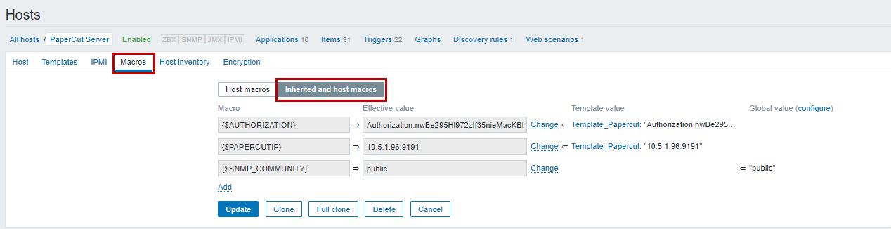
2. Click **Change** and change the **Effective value** of the following **Macros**:  
   **{$AUTHORIZATION}** – Enter the authorization key of your PaperCut NG Application Server noted from the **Authorization - GET query parameter** of the PaperCut MF Admin web interface. For example, Authorization=tPEidXZQv4znKF8hUtpYYAEInIdtZKCe

**{$PAPERCUTIP}** – Enter the IP address of your PaperCut NG Application Server noted from the **Authorization - GET query parameter** of the PaperCut MF Admin web interface. For example, 10.250.64.127:9191  
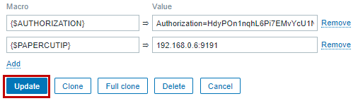

1. Click **Update**.
2. Navigate to **Configuration > Hosts** and clickthe PaperCut NG host (your just created).
3. Navigate to **Macros > Host macros.**
4. Verify that the **Effective value** of the **{$AUTHORIZATION}** and **{$PAPERCUTIP}** macro are the same asthose you just updated on the **Macros > Inherited and host macros** page.

## Step Seven – Install the Zabbix agent on the PaperCut NG Application Server

### On Windows:

To install the Zabbix agent on the PaperCut NG Application Server on Windows:

1. On your Windows PaperCut NG Application Server, in the following path, create a Zabbix folder:  
   C:\zabbix  
   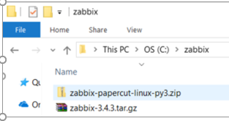
2. Navigate to:   
   <https://www.zabbix.com/download>
3. From the Zabbix Sources section, select the latest and click **Download**: 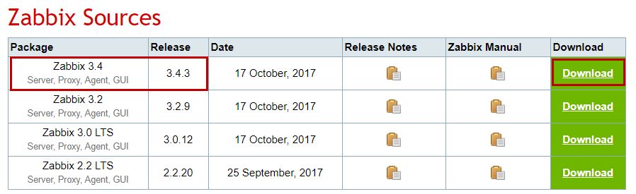
4. Save the downloaded file in to the Zabbix folder that you just created:

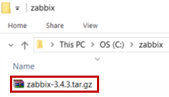

1. Navigate to [https://github.com/<<](https://github.com/%3c%3c) >>
2. Click **Clone or download > Download Zip:**   
   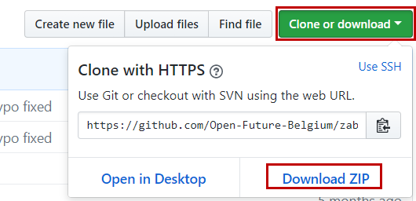
3. Save the downloaded file **zabbix-papercut-linux-py3.zip** in to the Zabbix folder that you just created:

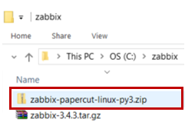

1. Navigate to [https://github.com/<<](https://github.com/%3c%3c) >>
2. Click **Clone or download > Download Zip:**   
   
3. Save the downloaded file **PcZabbixAgentPy3.py** in to the Zabbix folder that you just created:

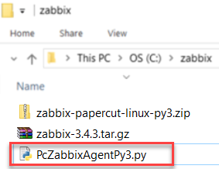

1. Navigate to the Windows Start menu.
2. Right-click the **Command Prompt.**
3. Select **Run as administrator**.
4. Run the following commands:   
   cd c:\zabbix\  
   python PcZabbixAgentPy3.py  
   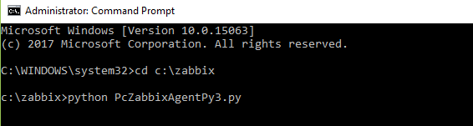
5. Enter the following responses to the script’s wizard:

|  |  |
| --- | --- |
| Enter PaperCut System Health Monitoring URL: | Enter the URL of your PaperCut NG Application Server noted from the **Authorization - GET query parameter** of the PaperCut MF Admin web interface.  For example, http://10.250.64.127:9191/api/health?Authorization=tPEidXZQv4znKF8hUtpYYAEInIdtZKCe |
| Enter Zabbix Server IP address [127.0.0.1]: | Enter the IP address of your Zabbix Server. If nothing is entered, then 127.0.0.1 is used. |
| Enter Zabbix active Server IP address []: | Enter the same IP address as entered for Enter Zabbix Server IP address. If nothing is entered, then the same IP address as entered for Enter Zabbix Server IP address is used. |

1. Verify that the Zabbix agent is installed successfully:  
   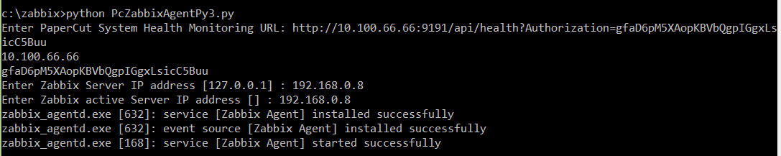

### On Linux:

To install the Zabbix agent on the PaperCut NG Application Server on Linux:

1. On your Linux PaperCut NG Application Server, navigate to the **Linux Shell Command Terminal**.
2. Run the following commands:

# Create the Zabbix repository

rpm -Uvh <http://repo.zabbix.com/zabbix/3.4/rhel/7/x86_64/zabbix-release-3.4-1.el7.centos.noarch.rpm>

# Install the Zabbix agent

yum install zabbix-agent -y

# Start the Zabbix agent

systemctl start zabbix-agent.service

1. Verify that the Zabbix agent is installed and started successfully:

# Confirm the Zabbix agent has started

systemctl status zabbix-agent.service

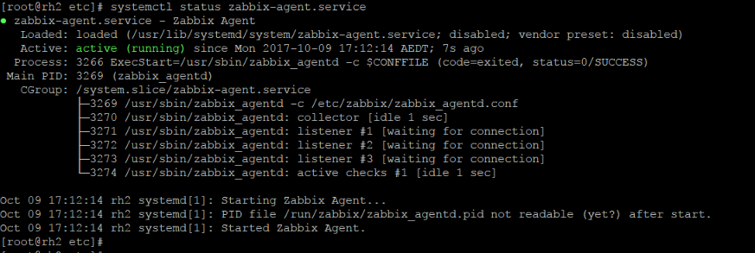

1. Run the following command:  
   # Set up the Zabbix agent to start by default at startup

systemctl enable zabbix-agent.service

1. Verify that the Zabbix agent starts by default after the PaperCut NG Application Server is started:



1. Navigate to [https://github.com/<<](https://github.com/%3c%3c) >>
2. Click **Clone or download > Download Zip:**   
   
3. Save the downloaded file **zabbix-papercut-linux-py2.zip** in the Zabbix directory: /etc/zabbix/ and extract its contents:

<<screenshot>>

1. Locate the following file:   
   /etc/zabbix/papercut.conf
2. Edit the file as follows:

|  |  |
| --- | --- |
| papercut_ip= | Enter the IP address of your PaperCut NG Application Server noted from the **Authorization - GET query parameter** of the PaperCut MF Admin web interface. For example, 10.250.64.127:9191 |
| papercut_auth= | Enter the authorization key of your PaperCut NG Application Server noted from the **Authorization - GET query parameter** of the PaperCut MF Admin web interface.  For example, Authorization=tPEidXZQv4znKF8hUtpYYAEInIdtZKCe |

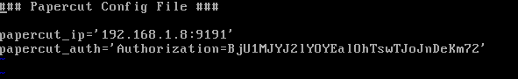

1. Locate the following file:   
   /etc/zabbix/zabbix-agentd.conf
2. Edit the file as follows (change the default values in the file):

|  |  |
| --- | --- |
| Server=127.0.0.1 | Enter the IP address of your PaperCut NG Application Server noted from the **Authorization - GET query parameter** of the PaperCut MF Admin web interface. For example, 10.250.64.127:9191 |
| ServerActive=127.0.0.1 | Enter the IP address of your Zabbix Server. |
| Hostname= | Enter the hostname of your PaperCut NG Application Server. |

1. Add the following parameter (to enable support for UnsafeUser parameters, the “/” in printer names) in the last line of the file:UnsafeUserparameters=1  
   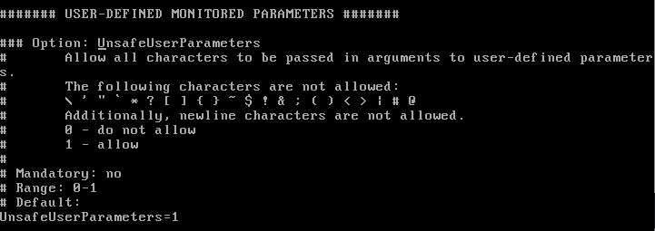
2. Run the following command:  
   # Restart the Zabbix agent on the PaperCut NG Application Server

systemctl restart zabbix-agent.service

## Step Eight – Verify PaperCut NG System Health is monitored by Zabbix

To verify that your PaperCut NG System Health can be monitored by Zabbix:

1. Access the Zabbix Server Admin web interface.
2. Navigate to **Monitoring > Latest data**:  
   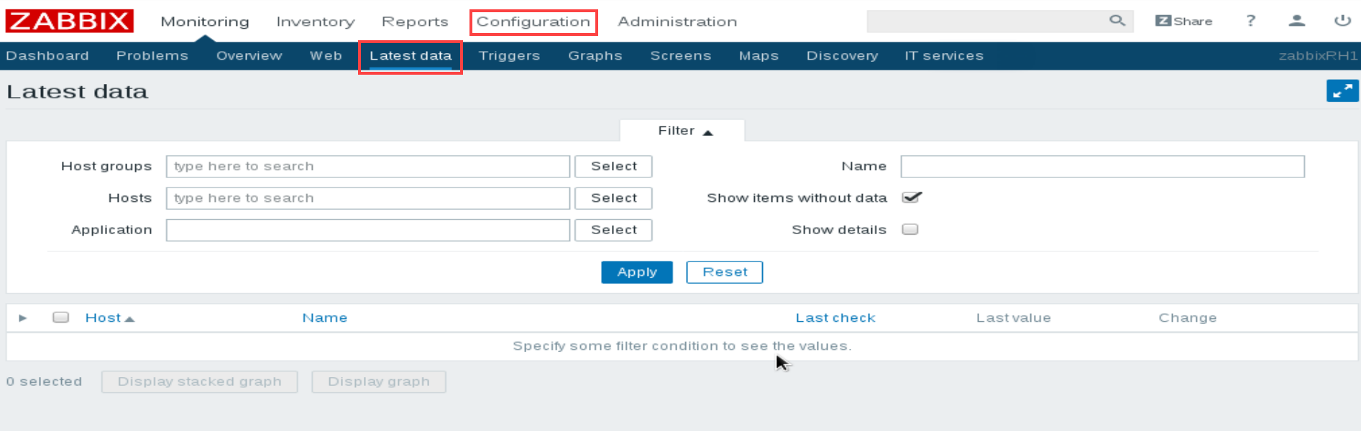
3. On the **Hosts** field, click **Select**:  
   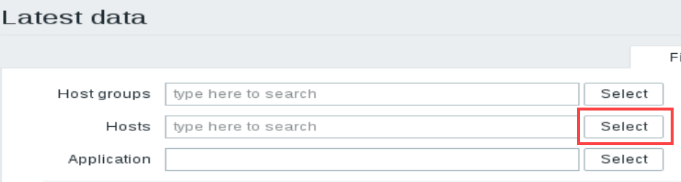
4. From the **Group** drop down, select the PaperCut host group:  
   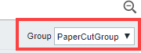
5. From the **Hosts** section, check the **PaperCut Server** option and click **Select**:   
   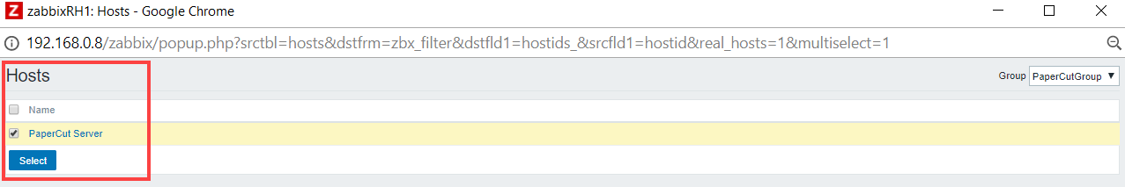
6. Click **Apply**:  
   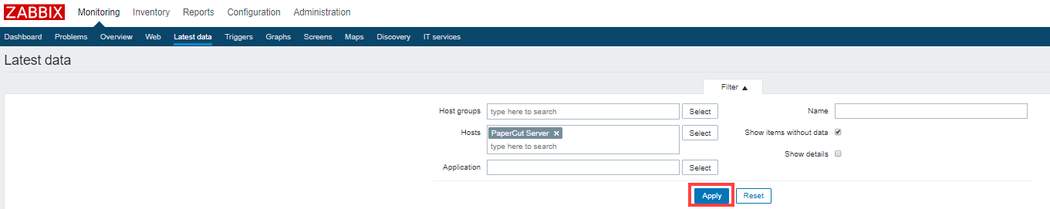
7. Verify that the most recent data from your PaperCut NG Application Server is displayed on the **Last check** and **Last value** columns:  
   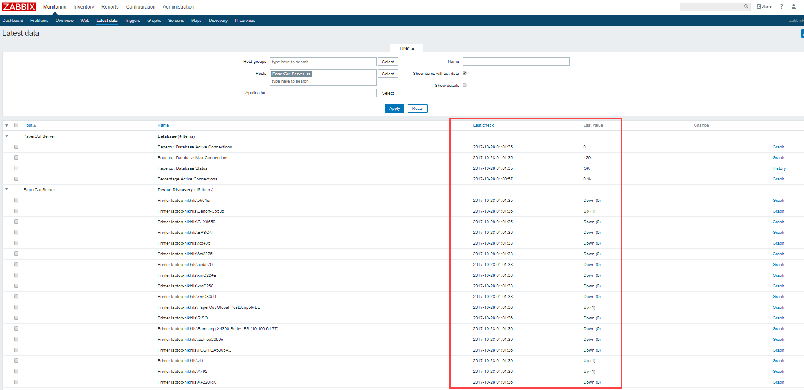

**Note:** If the most recent data from your PaperCut NG Application Server is *NOT* displayed on the **Last check** and **Last value** columns, then resolve the issue based on the cause:

|  |  |
| --- | --- |
| **Cause** | **Resolution** |
| The hostname of your PaperCut NG Application Server is incorrect in any one or both of the following places:   * **Step Four – Create a PaperCut NG host on the Zabbix Server Admin web interface** * **Step Seven – Install the Zabbix agent on the PaperCut NG Application Server** | Ensure that hostname of your PaperCut NG Application Server has been entered correctly. |
| Zabbix Server fails to communicate with your PaperCut NG Application Server on the port specified in **Step Four – Create a PaperCut NG host on the Zabbix Server Admin web interface.** | Ensure that port specified is correct and that the Zabbix server is able to communicate with your PaperCut NG Application Server on that port. |